Use a project in another project by putting dependency in xml file

parallelStream

flatMap

Why use in java Builder or build

ResponseEntity(Handling httpstatus)

JWT token

Practical

Cookies

Session

AWS cloud

Pagination

JWT token

Build tool, maven , ant

Spring

Spring MVC

Spring Boot

Lazy Loading, early loading

Microservices,web client, kafka, REST API

Next topic

Spring security

JWT token

Spring web devtool dependency

Entity association in pring Boot

@Qualifier in springboot, Spring security

Collections in java

Java 8 features

Jenkins

Sonar

Docker

Kubernet

Generate pdf in java

Generate csv in java

API and it’s type

Junit testing

SOLID principal

Design patterns

HLD

LLD, Gradle

**Hibernate**

* Create session and give configuration file in the session.
* Give database information in the configuration file.
* Map the entity class in this file.
* When have to perform database operation:

1. Get session
2. Get Transaction and begin
3. Perform operation. Exapmle:-

SessionClass.*getSession*().getTransaction().begin();

queryToDB = Constant.*queryByPrice*;

query =SessionClass.*getSession*().createQuery(queryToDB,TShirtEntity.class);  
  
query.setParameter("color", color);  
query.setParameter("size", size);  
query.setParameter("gender", gender);

SessionClass.*getSession*().getTransaction().commit();

Hibernate query example:

static String *queryByPrice* = "from TShirtEntity s where s.color=:color and s.size=:size and s.genderRecommendation=:gender order by s.price";

**Servelet**

* Tomcat server need to run servlet
* Session for every model(Entity) can be created in DAO

public class UserDao {  
 private Session session = null;  
  
 // Constructor  
 public UserDao() {  
 Configuration con = new Configuration().configure().addAnnotatedClass(User.class).addAnnotatedClass(Product.class);  
  
 ServiceRegistry reg = (ServiceRegistry) new StandardServiceRegistryBuilder().applySettings(con.getProperties())  
 .build();  
  
 SessionFactory sf = con.buildSessionFactory(reg);  
 session = sf.openSession();  
 }  
  
 // Get User From the Database

* To perform database operation, we need to do following:

1. Get transaction by session
2. Begin transaction
3. Perform database operation
4. Commit transaction

* Don’t need to add database configuration file in class for creating session as it detects automatically. File name is: hibernate.cfg.xml
* We need web.xml file to declare servlet and mapping url. Example:

<servlet>  
 <servlet-name>LoginService</servlet-name>  
 <servlet-class>com.nagarro.training.assignments.WebAppAssignment3.services.LoginService</servlet-class>  
</servlet>  
  
<servlet-mapping>  
 <servlet-name>LoginService</servlet-name>  
 <url-pattern>/login</url-pattern>  
</servlet-mapping>

* Using this we can use class from view. Means from jsp file. In below example this will call login servlet. And the login servlet has been mapped by LoginService class.

<form action="login" method="post">  
 <div class="form-div">  
 <table>  
 <tr>  
 <td class="td-label">Username:</td>  
 <td class="td-input"><span style="color: #f41f1f;">*</span>  
 <input type="text" name="username" />  
 <% if (session.getAttribute(Constants.USERNAME_ERROR_FIELD) != null) {  
 %>  
 <small style="color: #f41f1f; margin-left: 1em;"> <%=session.getAttribute(Constants.USERNAME_ERROR_FIELD)%>  
 </small> <%  
 session.removeAttribute(Constants.USERNAME_ERROR_FIELD);

**Maven**

* Build tool
* Download external library. Example:

If we need to connect MySql database we need MySql conector library. We can add this library manually but it create bottleneck. But can do this by dependency by just putting in pom.xml file i.e is maven file.

* Many other benefits

**Spring**

* **Dependency Injection –**

Let’s there are two class Car and Bike and both are implementing Vehicle interface. If I want to inject object of this class in main method without new then we need to create a bean for this and also add ApplicationContext in main method.

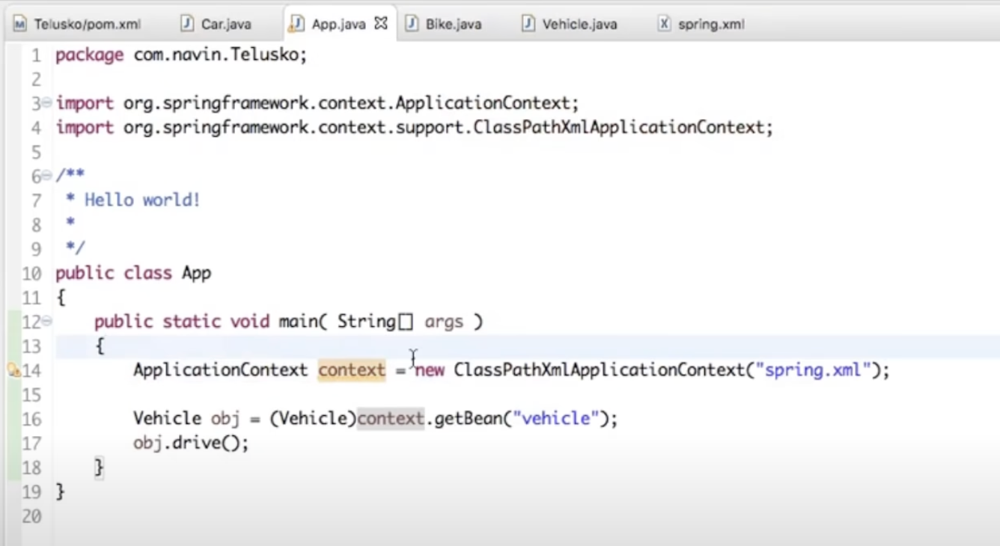

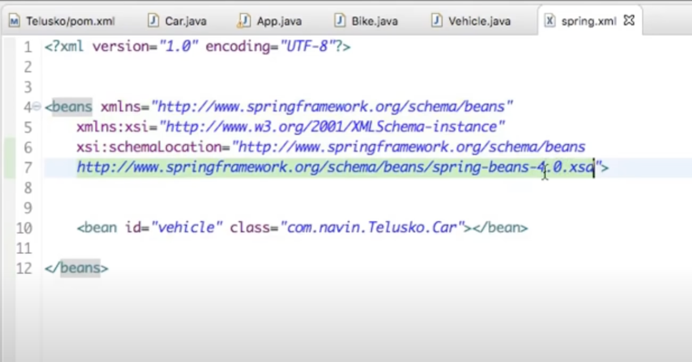

In main method, object of Car will be created. To create object of Bike I need to modify bean from Car to Bike.

‹ bean id="vehicle" class="com.navin.Telusko.Bike"></bean>

* In the Spring framework, the interface ApplicationContext represents the IoC container. The Spring container is responsible for instantiating, configuring and assembling objects known as beans, as well as managing their life cycles
* The above is xml based configuration where we need to specify bean name but we can do this Annotation based configuration where we don’t need to create bean in xml just put @Component on the Bike and Car class. But tell the xml that we are using annotation based configuration by writing

‹context: component-scan base-package='com.navin.Teluska"> </context: component-scan>

* **Setter** injection:

‹bean id-"tyre" class="com.navin. Telusko. Tyre">

‹property name-"brand" value-"Ceat"></property>

</bean>

* **Constructor** Injection:

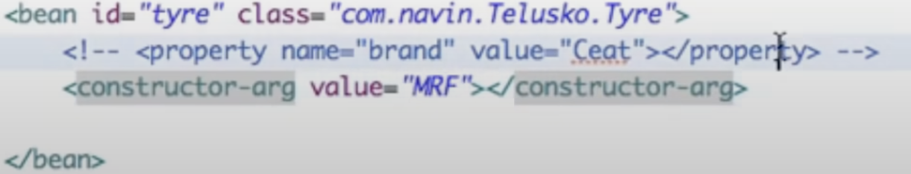

* We can use @Autowired to create bean.
* Another way to create bean. Not need to specify in xml file. Create a configuration Java class:

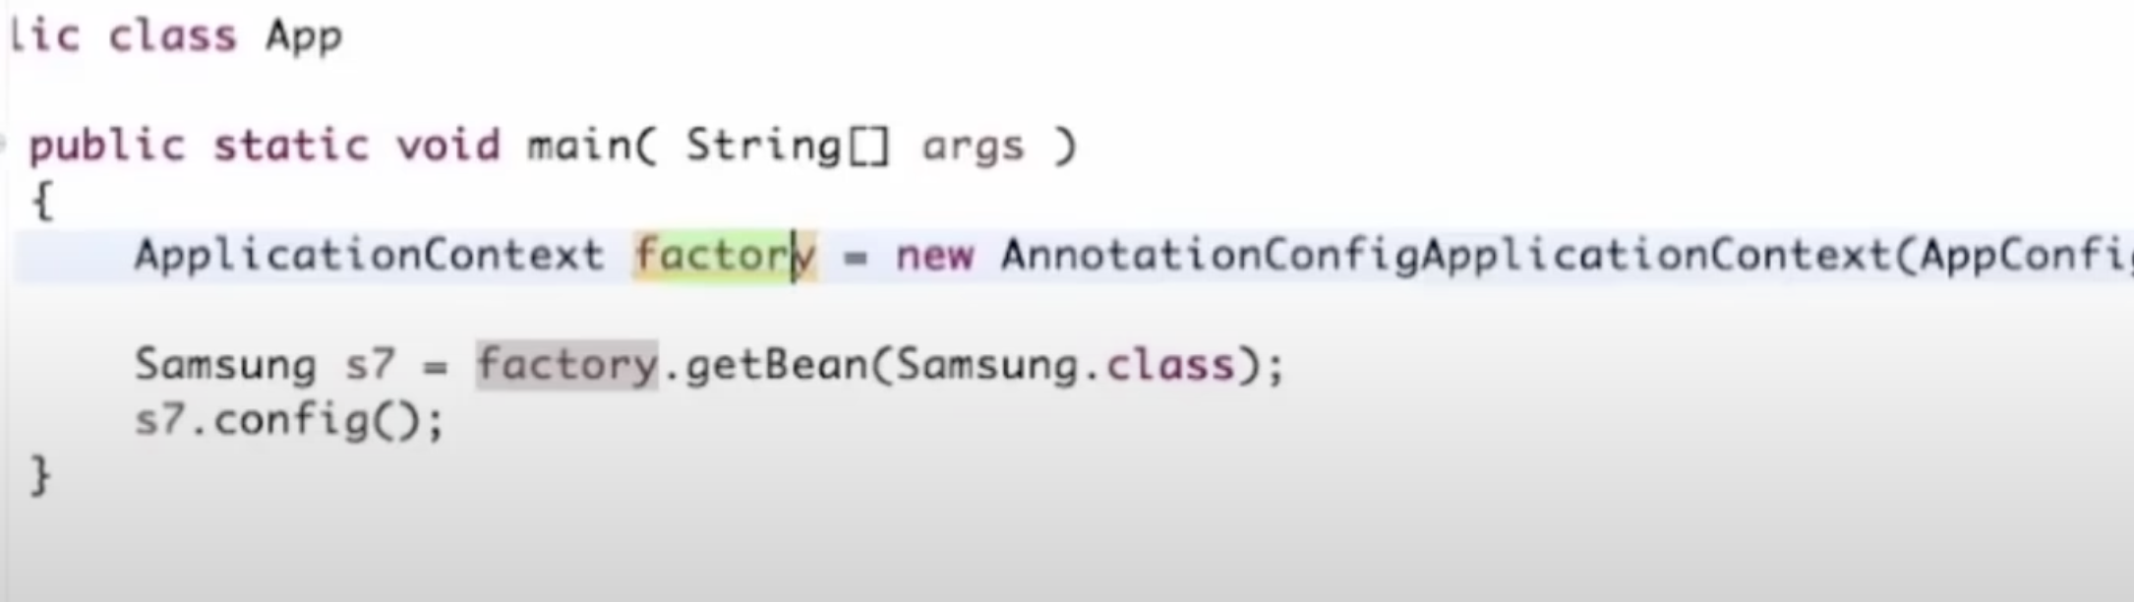

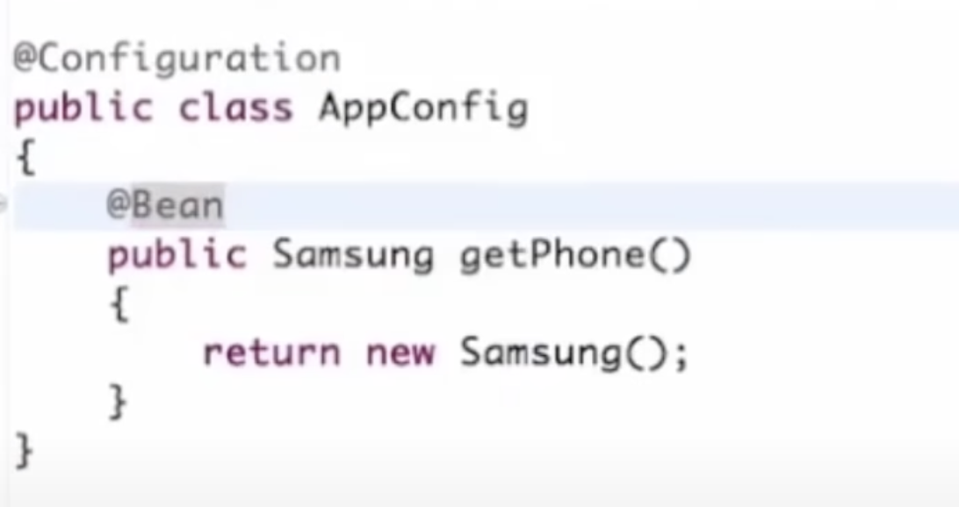

* Let’s discuss a scenario, where two class(Snapdragon and MediaTeck) implements same interface(MobileProcessor) and I want to create an object sing MobileProcessor. We can do this in two ways:
  + - 1. Just add @Primary annotation to the class , you want to create object
      2. Add @Qualifier annotation where you want to create class of object and give name of bean of that class.
* @Component annotation make the class bean , so we do not need to explicitly create in xml file or Configuration class.

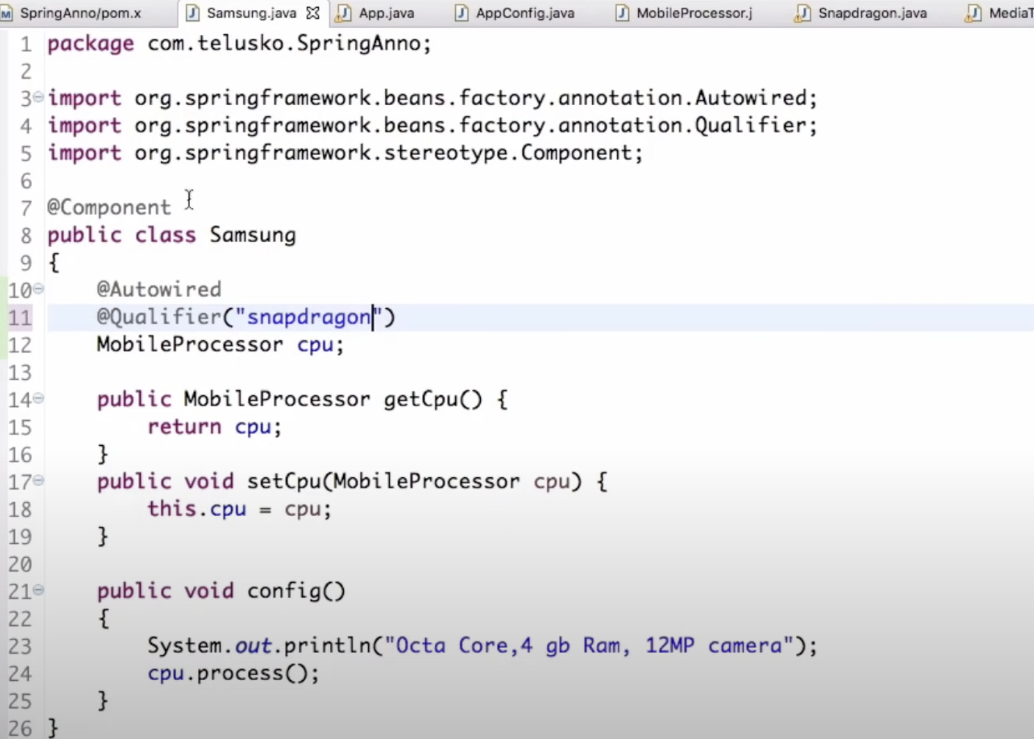

* **Advantage of dependency injection:**

1. decoupling the execution of a task from its implementation
2. making it easier to switch between different implementations
3. greater modularity of a program

**Spring ORM**

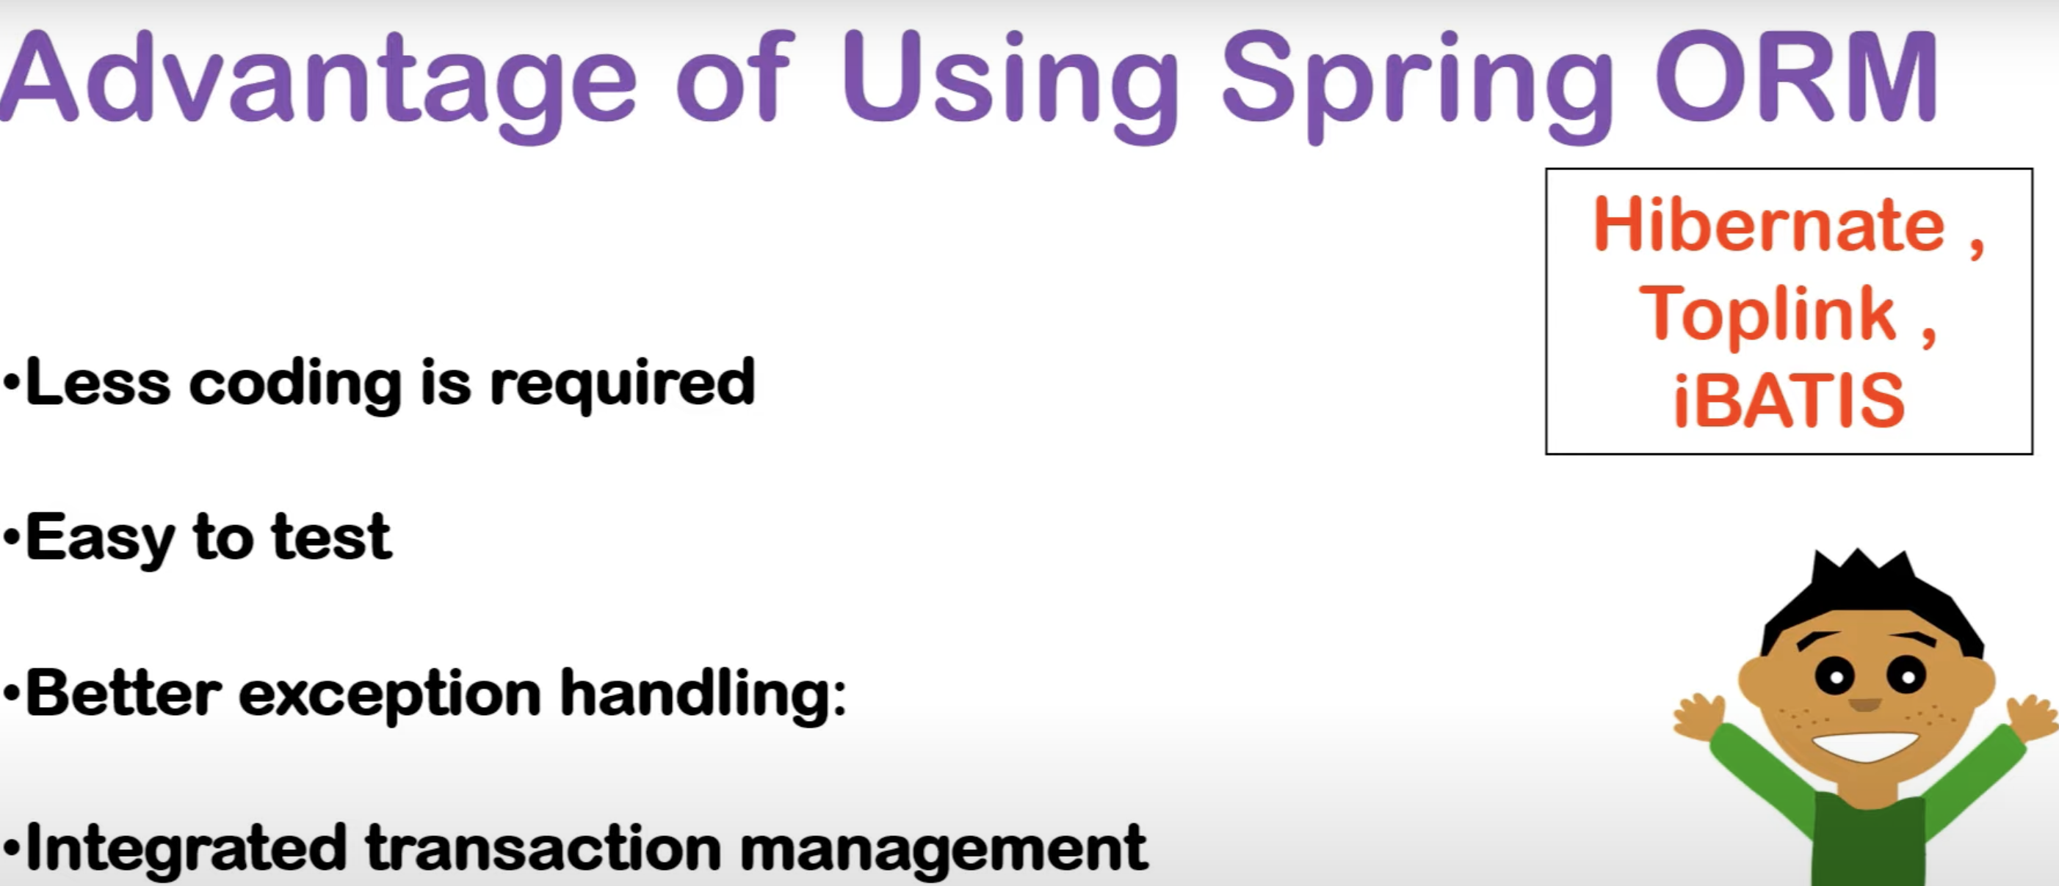

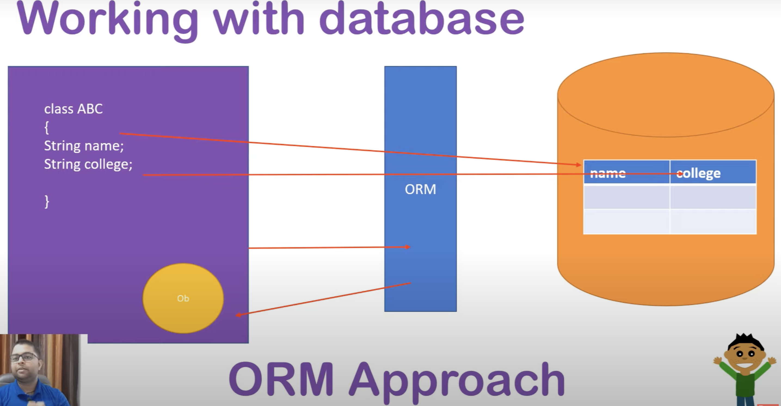

To use ORM in spring we need HibernateTemplate Class:

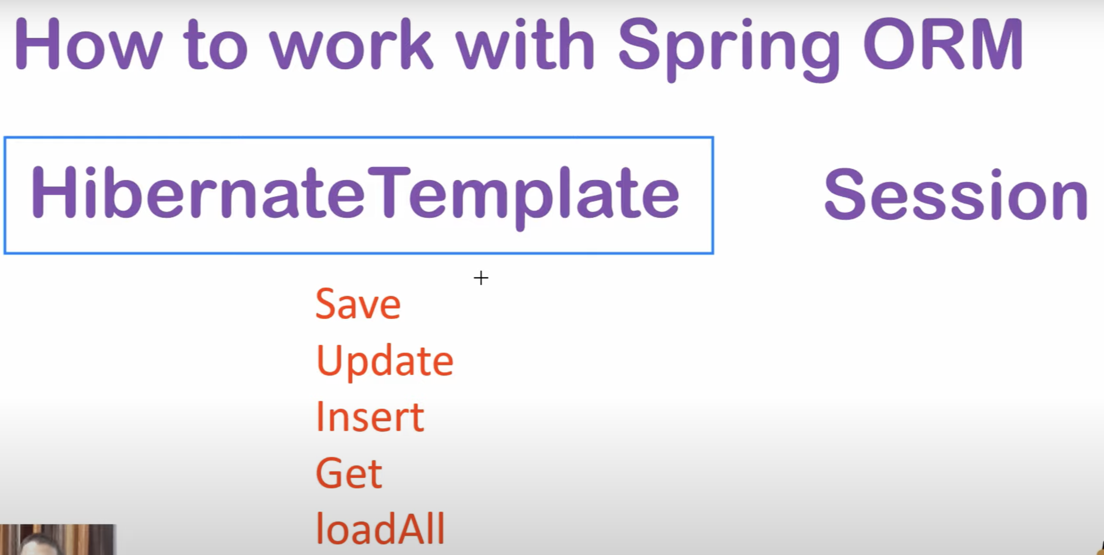

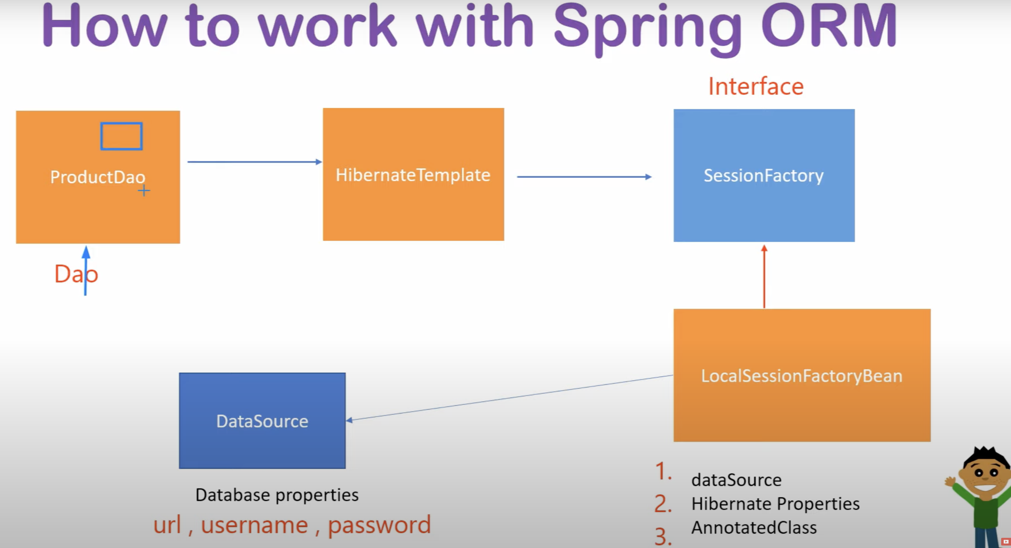

* To work with spring-orm we need below dependencies. Also need to add hibernate dependency.

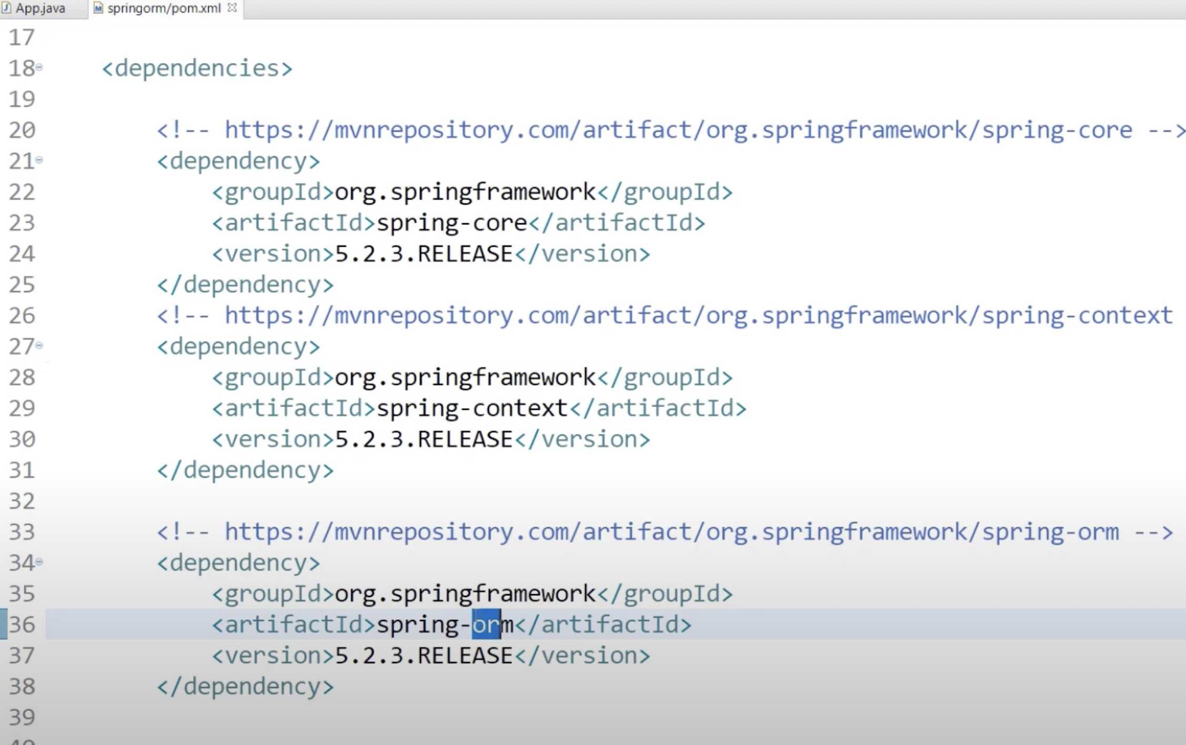

* To perform database operation we need to create a dao class and in this class by HibernateTemplate we can save, update , delete etc.

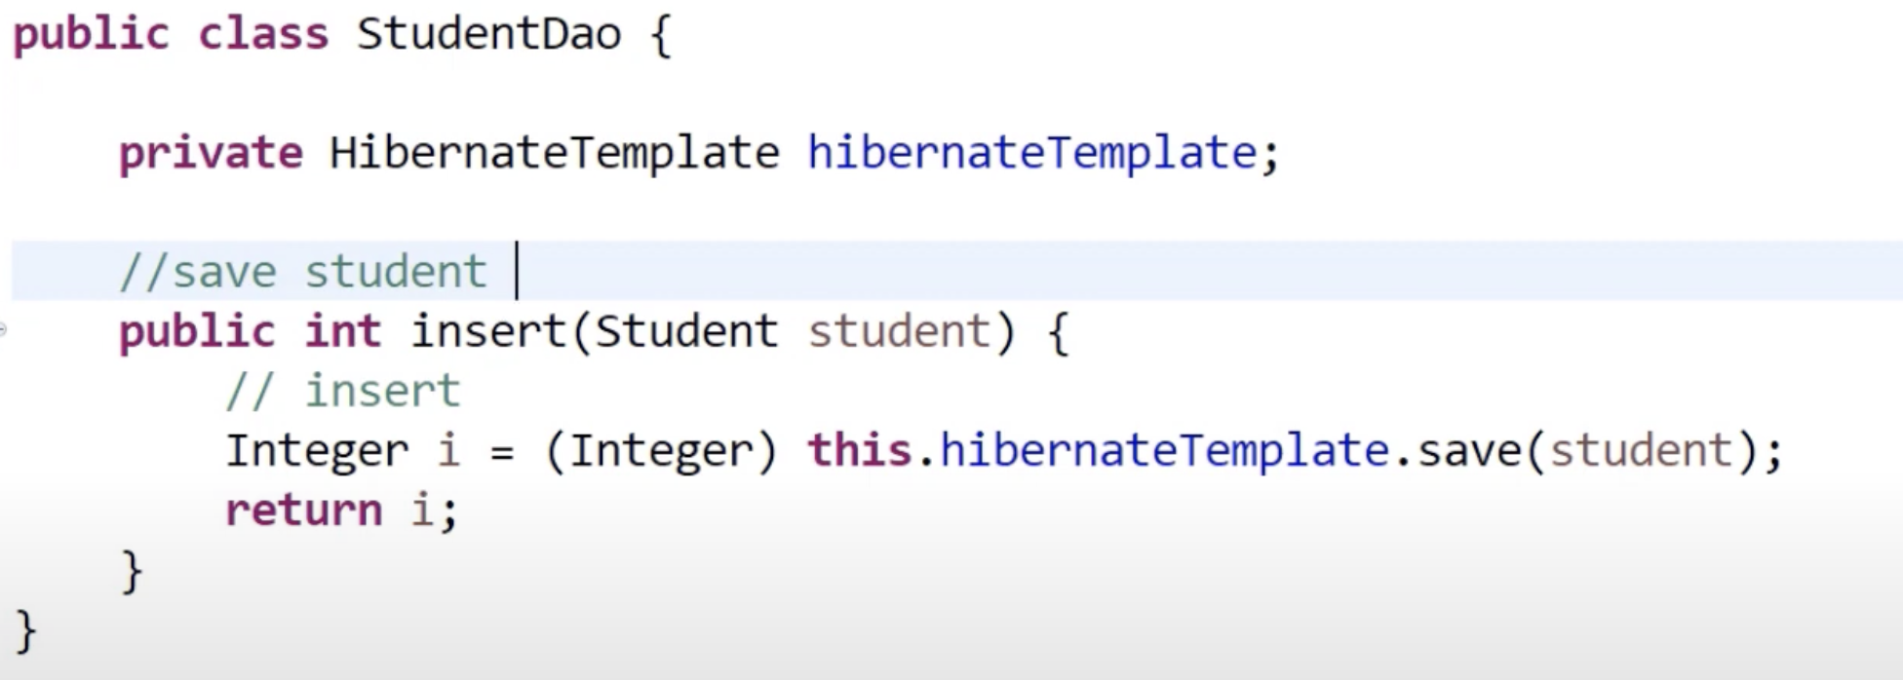

* Before perform database operation, xml file configuration is required , where database related configurations are done.

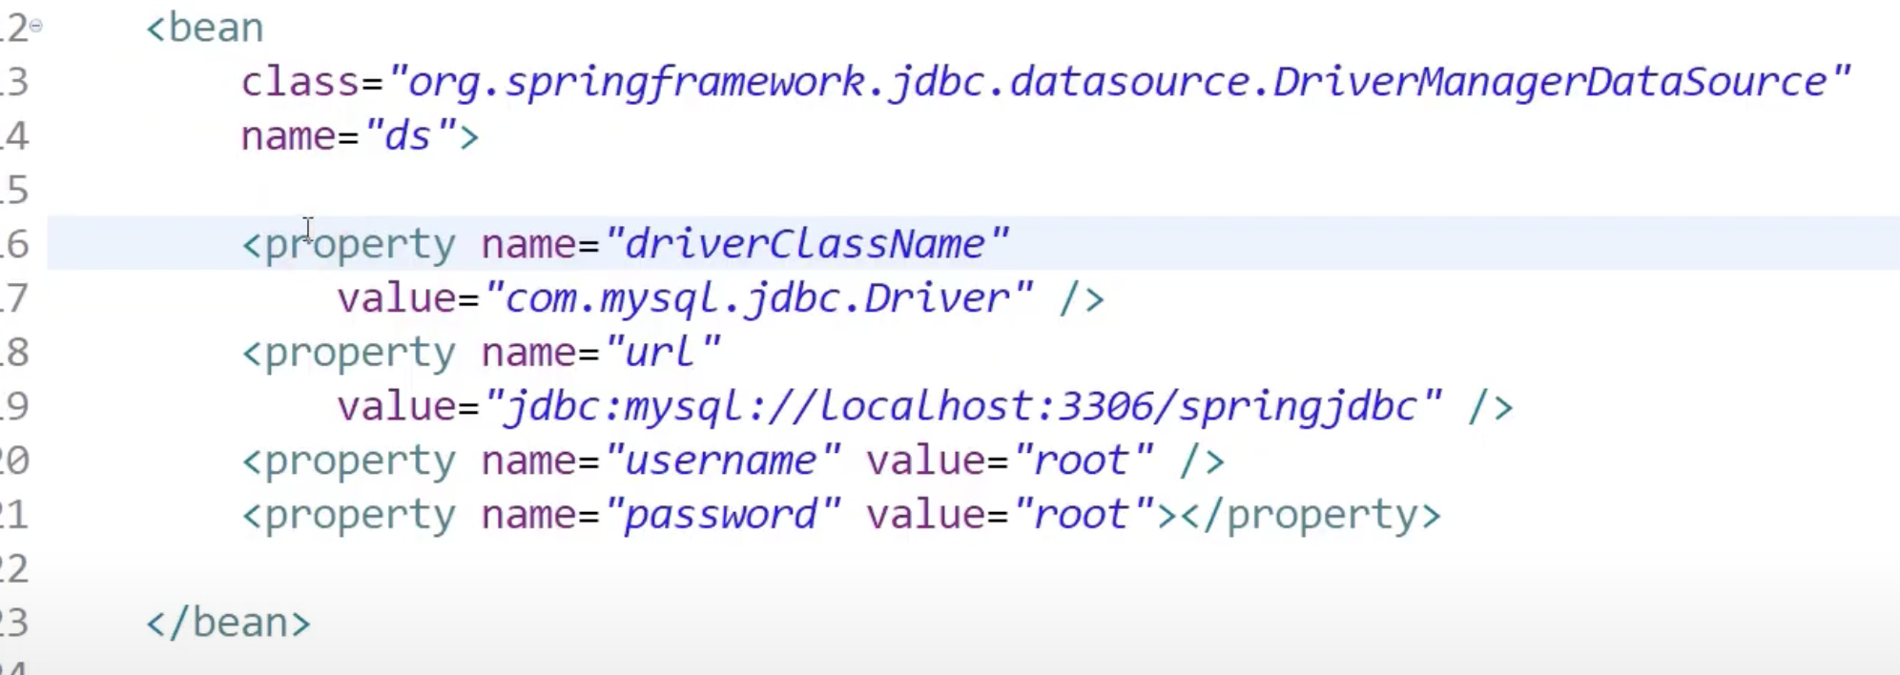

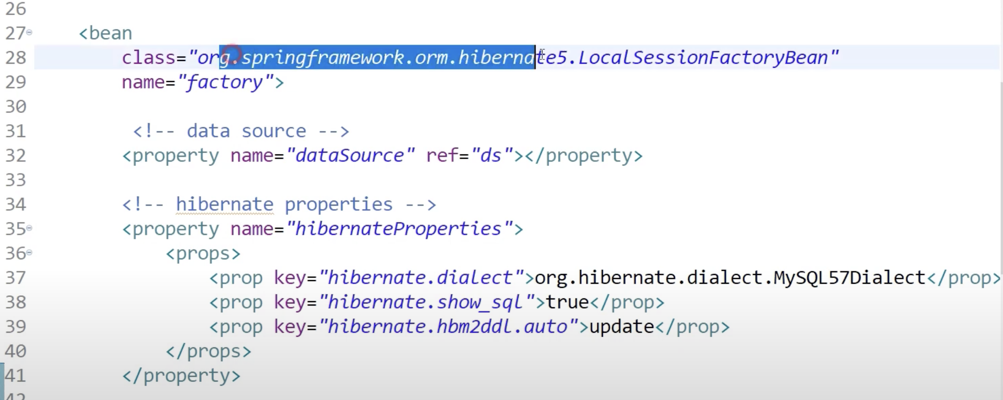

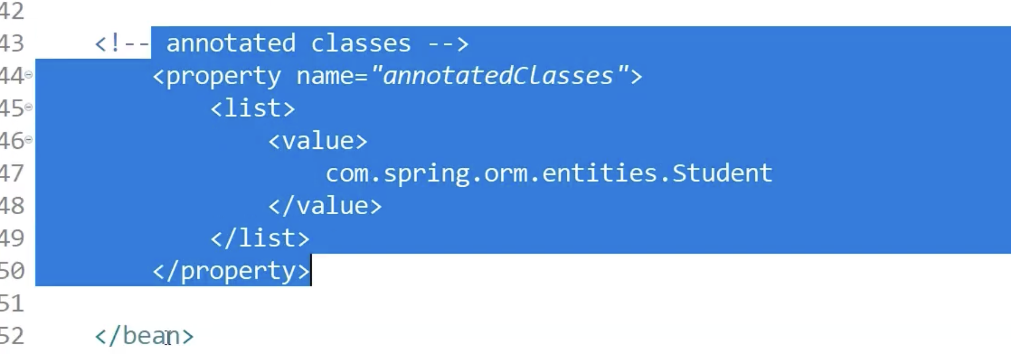

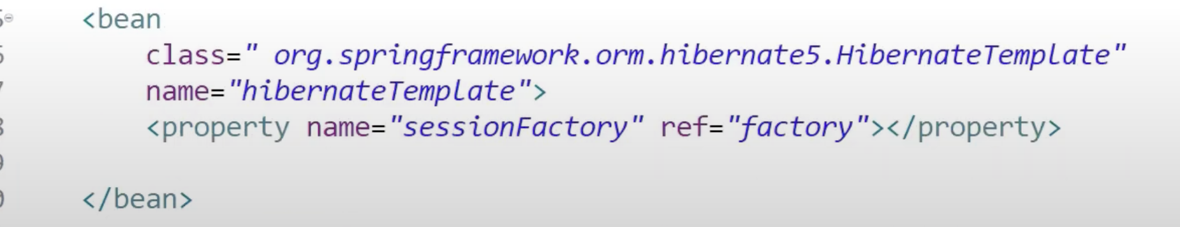

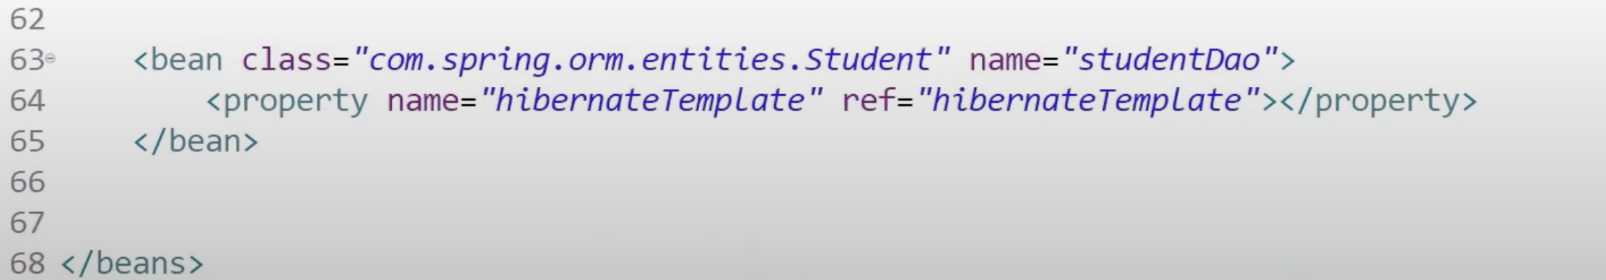

* Now, we can do database operation:

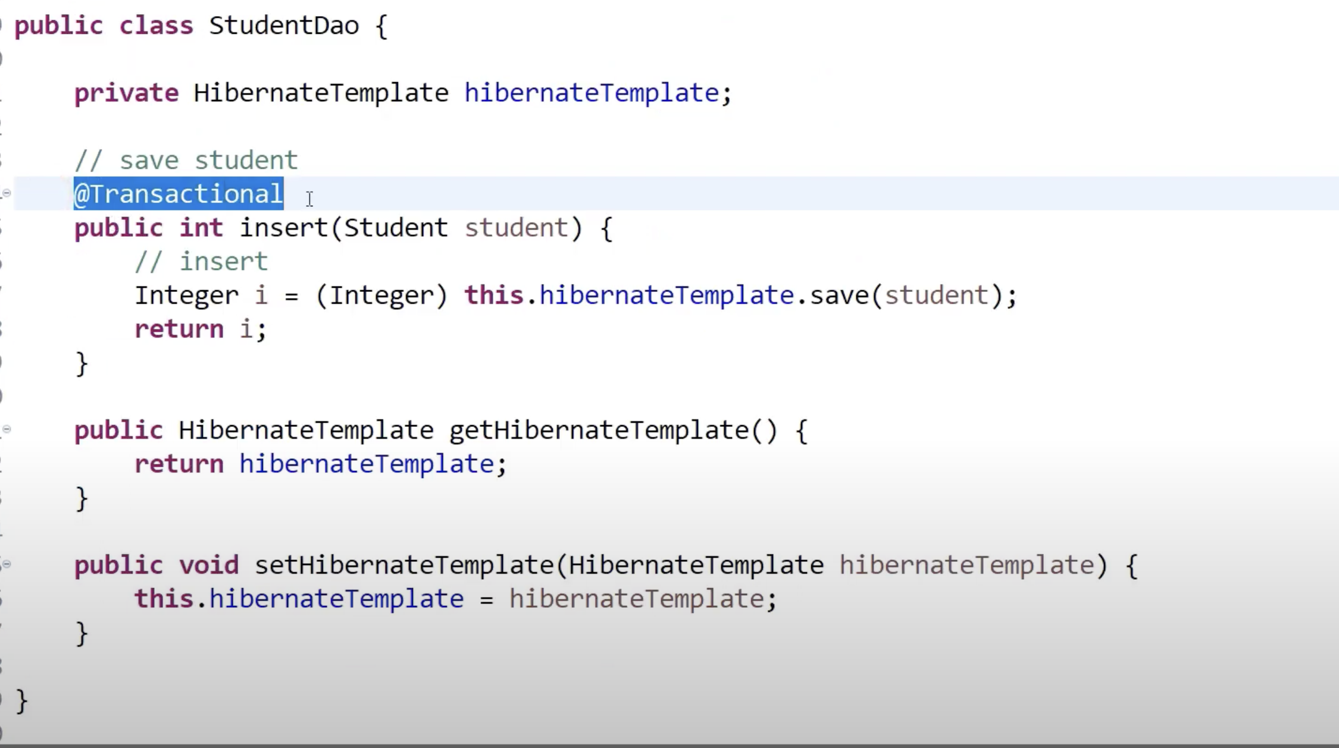

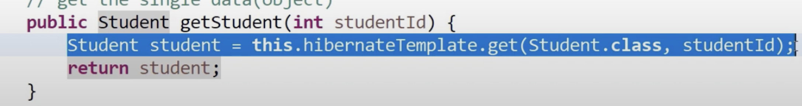

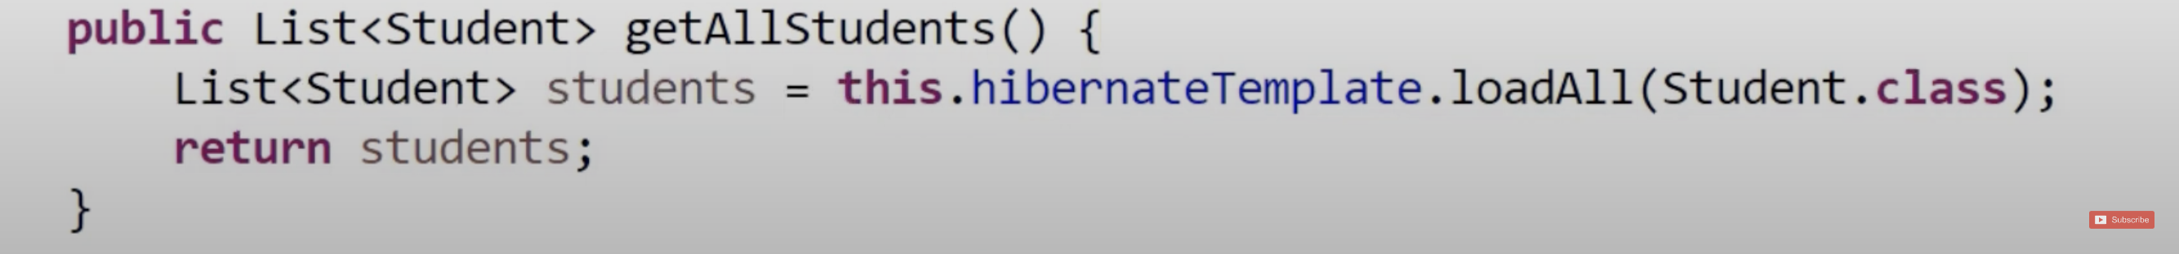

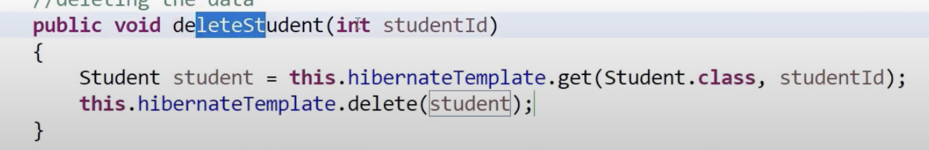

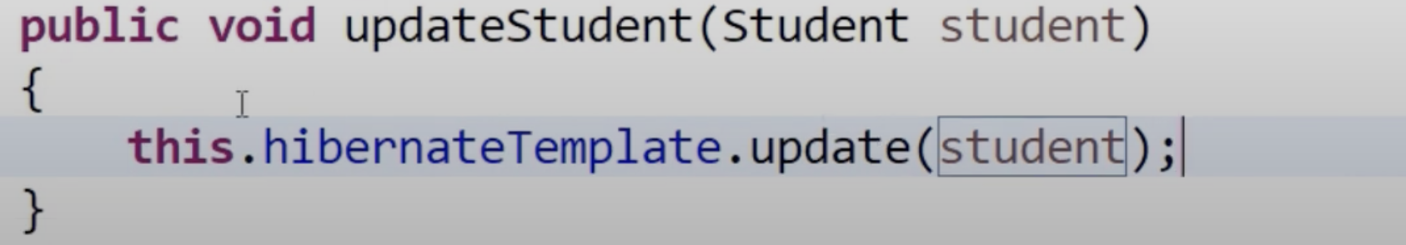

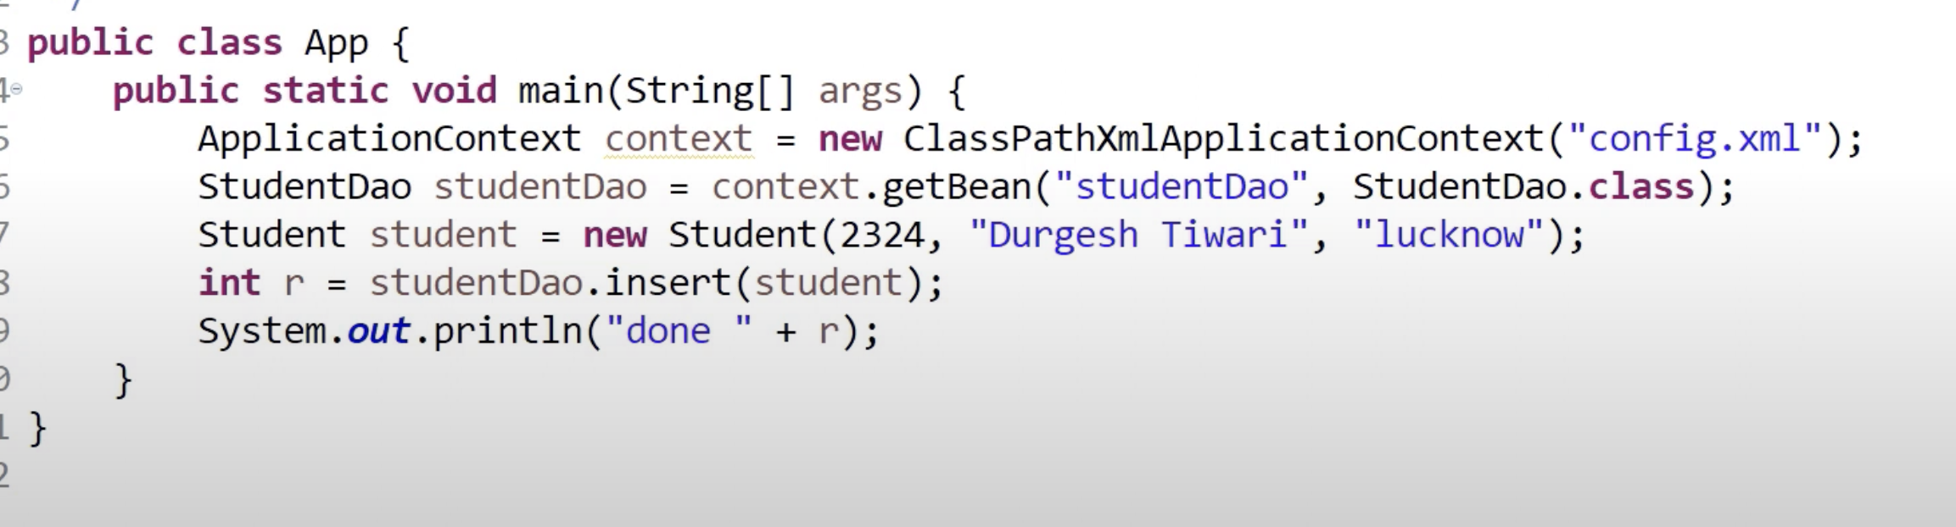

* To perform write operation add below bean:

